Healthy High School Start Times:
With Your Help, Fairfax Can Have Them Too!
FCPS School Board set a new goal to start high schools after 8:00 AM. Join health experts, parents, teachers, and students to voice your support for healthy start times -SIGN the PETITION at www.SLEEPinFairfax.org

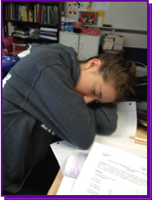
72 of 95 counties in Virginia have high schools that start at or later than 8:00 AM.
Fairfax County students start boarding buses at 5:45 AM. High schools start at 7:20 AM.

- Loudoun County high schools start at 9:00 a.m. and dismiss at 3:50 p.m.
It is possible to have competitive sports and activities with later dismissal times.
- Districts with start times like ours have significantly higher teen car crash rates.
- 1 in 4 Fairfax teens suffers from symptoms of depression.
- 2 in 3 Fairfax teens are severely sleep deprived (lose 2 or more hours of sleep every school night).
- Teens with later school start times sleep more than teens in Fairfax County.
- Adequate sleep improves learning, memory, and performance in school.

WHAT YOU CAN DO:
- Sign SLEEP’s petition
- Contact the School Board and tell them to change school start times.
- Join our email list at www.SLEEPinFairfax.org
- “Like” us on Facebook

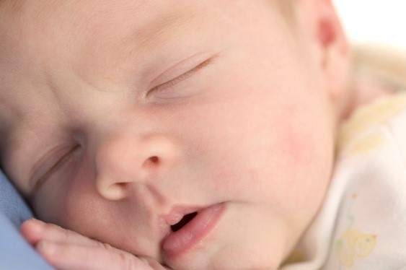
Join medical experts, parents, educators, and students who are pushing FCPS to provide what neighboring districts already have: rational bell schedules for all students K-12th grade that include reasonable schedules for sports.

People of all ages deserve the opportunity
to sleep when their bodies are ready for it.

How Do High School Schedules Work for Students?
Loudoun County High Schools Start at 9:00 a.m.
Fairfax County High Schools Start at 7:20-7:30 a.m.
Maria’s Schedule in Loudoun |  | Sean’s Schedule in Fairfax
SLEEPING | 5:00 a.m. | SLEEPING
SLEEPING | 5:30 a.m. | Alarm Rings
SLEEPING | 6:25 a.m. | Bus stop
SLEEPING | 7:00 a.m. | Arrives at school
Alarm Rings | 7:30 a.m. | SCHOOL STARTS 7:20-Calculus
Bus stop | 8:25 a.m. | Calculus Class
SCHOOL STARTS -Calculus | 9:00 a.m. | AP Spanish
AP Spanish | 10:35 a.m. | Lunch
AP Spanish (ongoing) | 11:10 a.m. | AP Literature
Lunch | 12:12 pm | AP Literature (ongoing)
AP Literature | 12:45 pm | AP Government
AP Lit (ongoing) | 2:05 pm | SCHOOL’S OUT
AP Government | 2:20 pm
AP Government (ongoing) | 3:00 pm | Cross Country Practice Starts
SCHOOL’S OUT | 3:48 pm
Cross Country Practice Starts | 4:00 pm
 | 5:00 pm | Practice Ends
Practice Ends | 6:00 pm
 | 6:15 pm
Dinner with family | 6:30 pm | Dinner with family
Teens with later morning start times fall asleep at about the same time at night as students who start school earlier in the morning and do sleep longer. The hormone required for sleep peaks later at night in teen brains—typically at about 11 at night.
LIGHT’S OUT | 11:00 pm | LIGHT’S OUT
8.5 hours of sleep |  | 6.5 hours of sleep
Testimonial from Loudoun Mom, Jane, “We love the late start schedule. Clearly there is a great deal of research that supports this approach for high school kids since they need so much more sleep at this age. We never have to argue in the morning about getting up like most parents and teens in other localities.”
The concept of later school start times is supported by: FCPS School Board, Fairfax County Council of PTAs, Fairfax County Federation of Teachers, League of Women Voters-Fairfax Area, FCPS School Health Advisory Committee, Medical Society of Northern Virginia, Coalition of the Silence, and 50+ (and growing) area pediatric practices, pediatricians, pediatric psychiatrists, and other health professionals.

